**Netherlands - Source URL Analysis**

**URL:** <https://www.officielebekendmakingen.nl/>

The website "Officiële bekendmakingen" (Official Publications) is a central place to examine a wide range of official publications from the various levels of the Dutch government, including Beschikking (Decree), Klein Koninklijk Besluit (Small Royal Decree), and Wet (Laws). The website provides easy access to publications from several sources, such as the Staatsblad (State Gazette), Staatscourant (Government Gazette), Tractatenblad (Treaty Series), Gemeentebladen (Municipal Gazettes), Provinciale bladen (Provincial Gazettes), Waterschapsbladen (Water Board Gazettes), and Bladen gemeenschappelijke regeling (Gazettes of Joint Regulations). Parliamentary documents are also included.

You can search by term, file number, or document type on the main page. Additionally, [Uitgebreid zoeken](https://zoek.officielebekendmakingen.nl/uitgebreidzoeken) (advanced search) provides access to its sophisticated search features, which include keyword, date, document type, publishing organization, publishing type, subjects, and categories.

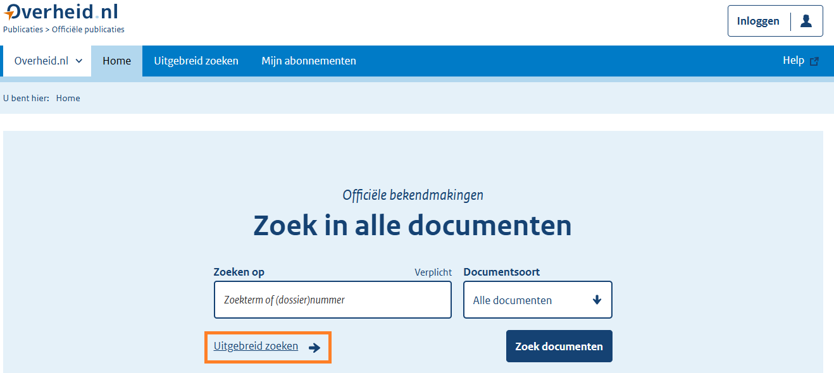

The "Uitgebreid zoeken" interface:

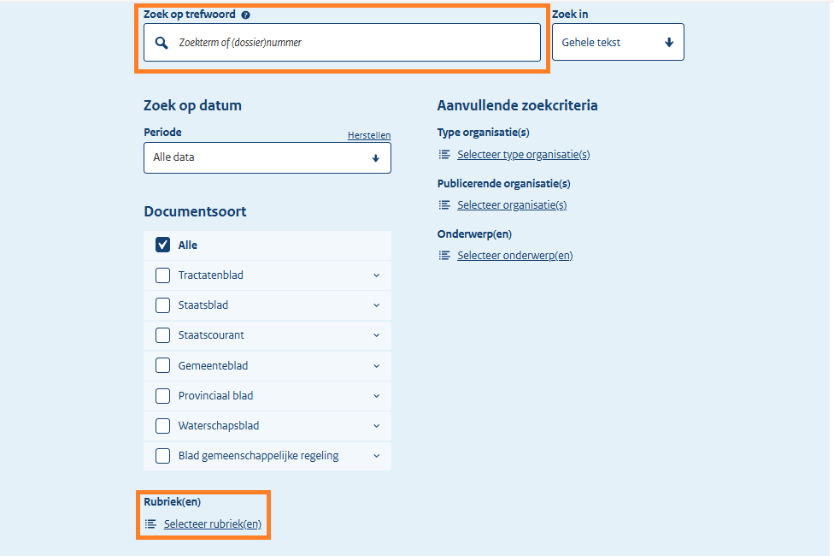

We can use the Search by Keyword (A) field to narrow down the search; it could be a term or file number. We used the following types of legislation in the Select Category (B) field: i.e. Laws (Wet), Decree (Beschikking), and Small Royal Decree (Klein Koninklijk Besluit).

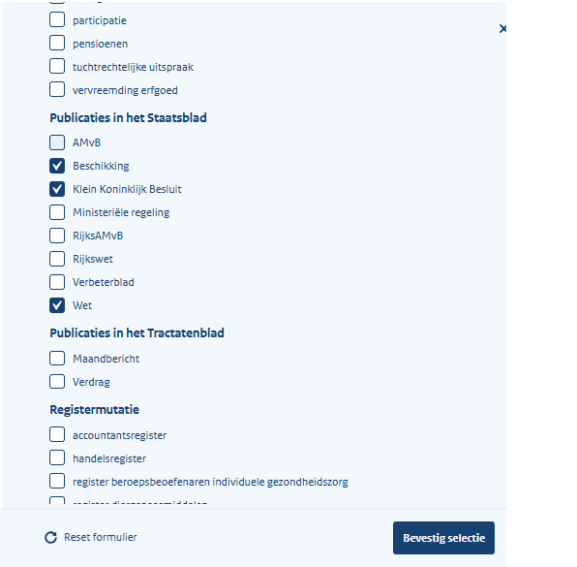

The necessary metadata is included in the site's content on the result page (apart from the adoption date).

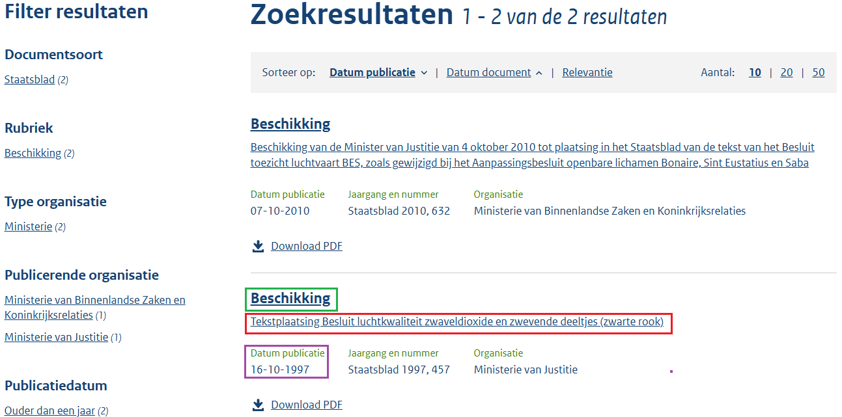

**Entry into Force Date**

**Original Title Source Link**

**Type of Regulation**

We must go to the specific legislation page to find the date of adoption, which can be found by glancing at the top of the page next to the entry of “Type of Regulation” which is the “The Header” (Rubriek).

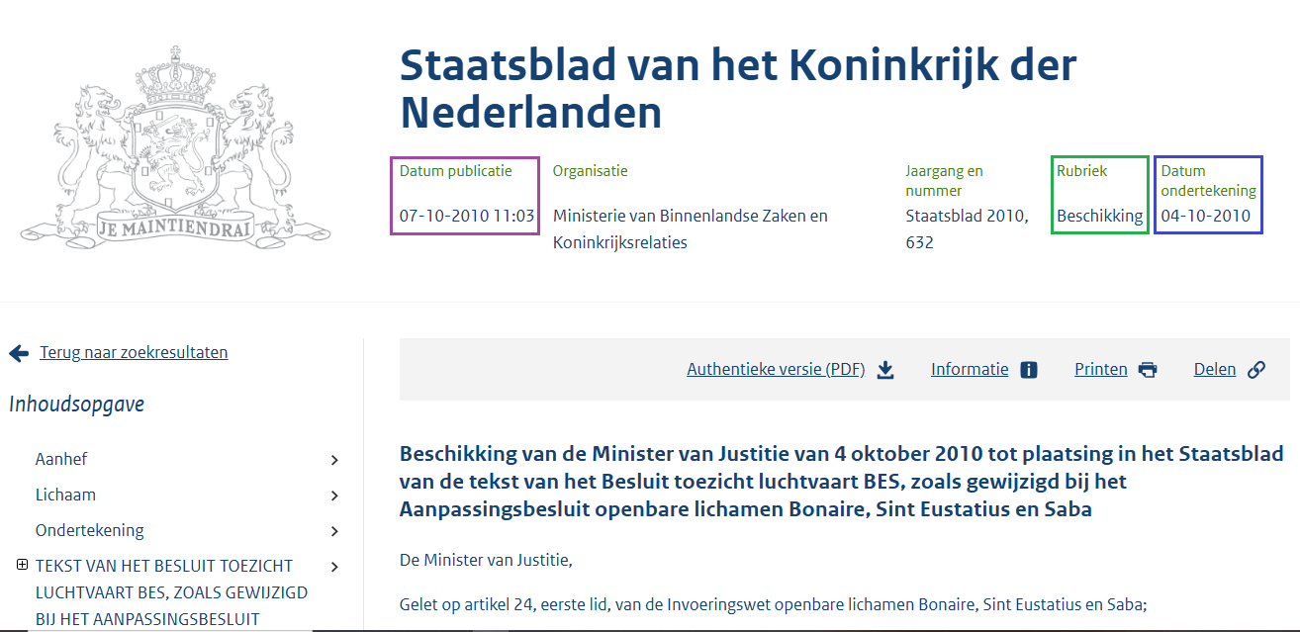

**Date of Adoption**

**Type of Regulation**

**Entry into Force Date**

The result page for several decrees clearly displays the original titles. For others, though, locating the original title necessitates visiting a particular legislation page, which is located directly beneath the date of issuance or entry into force date.

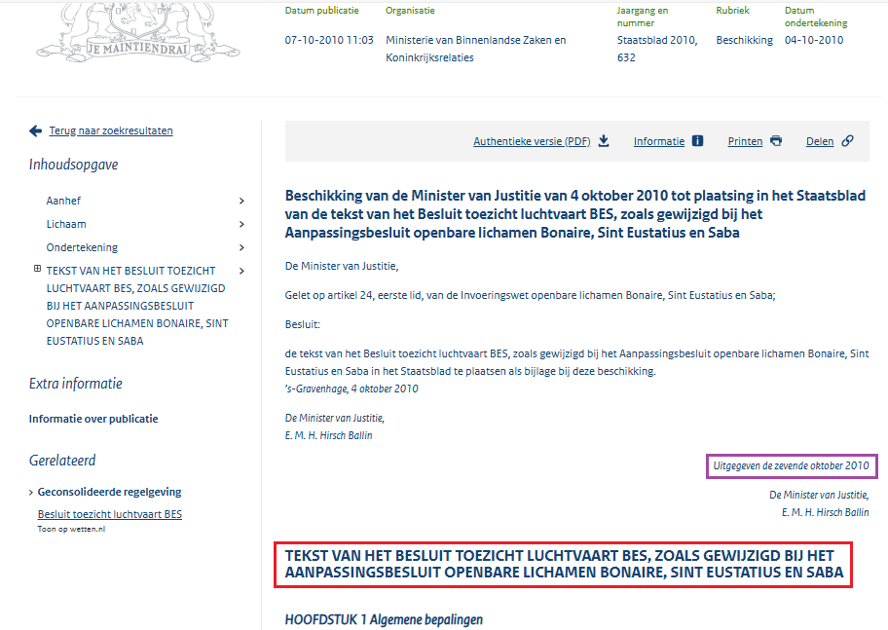

**Original Title**

Entry into Force Date

Certain laws and decrees that only have PDF versions and no web version have the required metadata displayed at the top of the page, with the exception of the original title, which appears at the bottom.

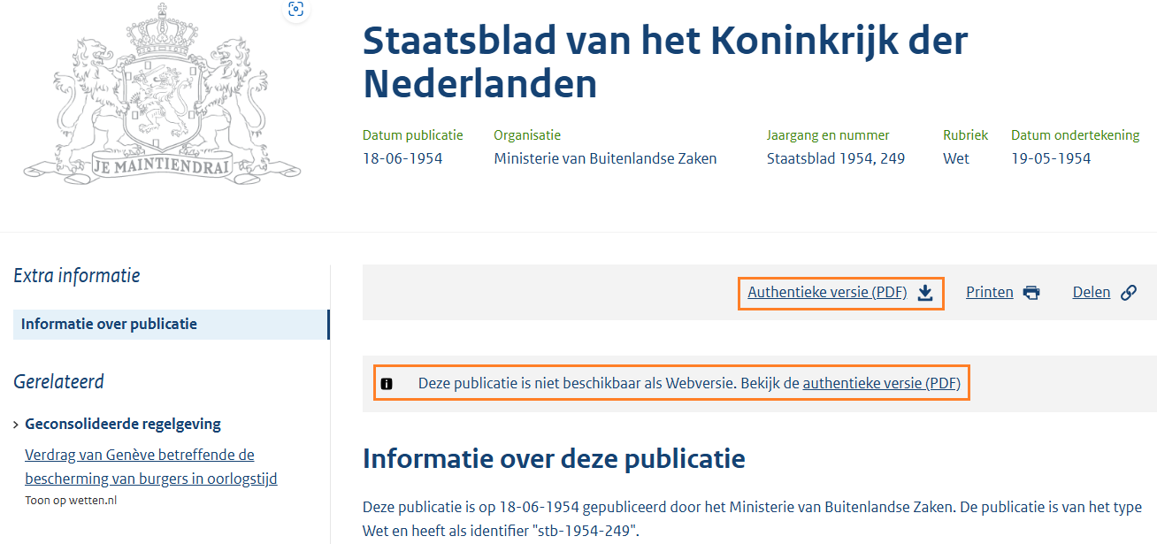Bottom of the page:

**No web version, only PDF.**

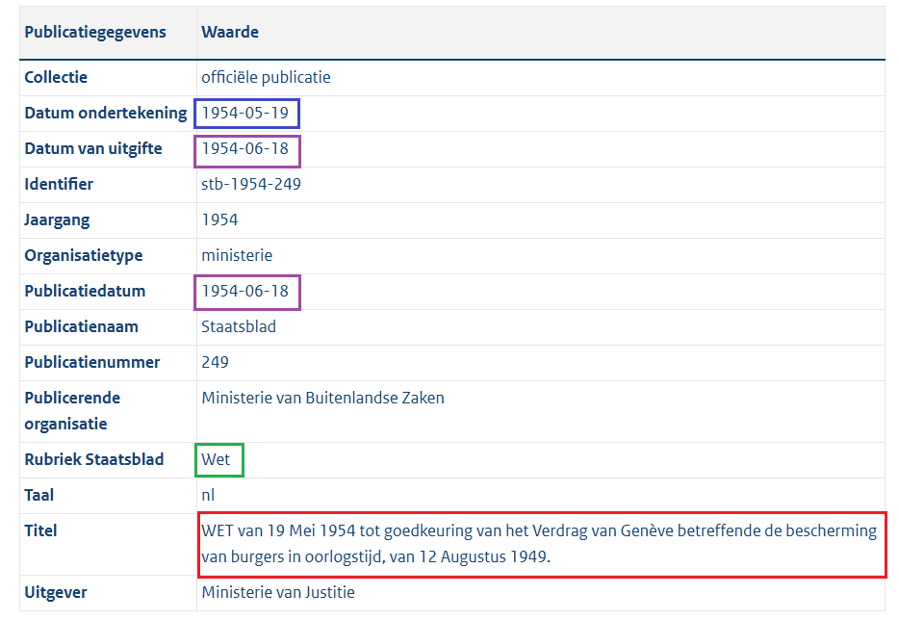The keywords or subtopics from the Title or Content fields can be entered in the Search field, depending on which yields the most pertinent results.

**Original Title**

**Type of Regulation**

**Date of Adoption**

**Entry into Force Date**

**Entry into Force Date**